

PIPELINE ROW PATROL INSPECTION REPORT

**Targa Resources (HGS)**  
Mont Belvieu, Highlands, Channelview, Baytown and Galena Park Areas

July 22, 2025

**CONFIDENTIAL DOCUMENTS**

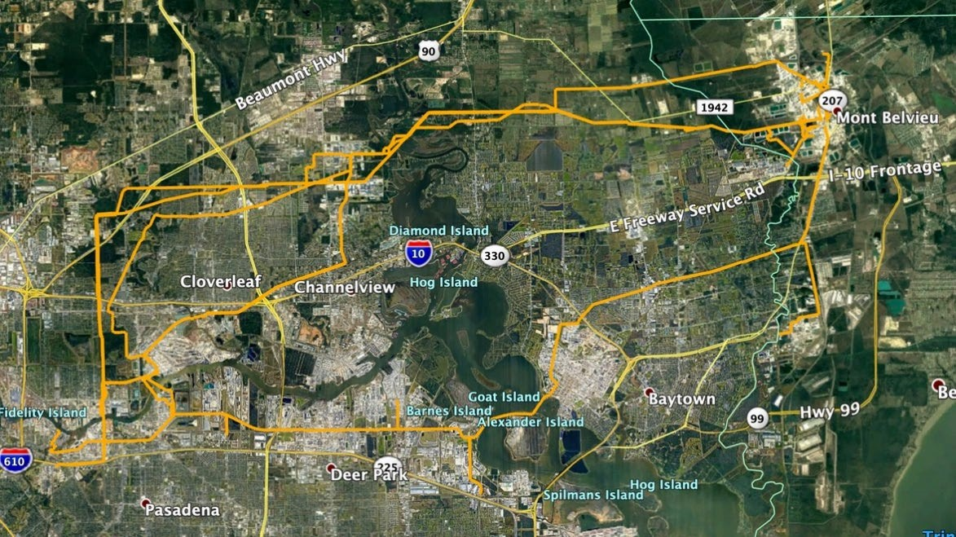

Arch Aerial, LLC

3801 Yale Street

Houston, TX 77018

281.974.5752